
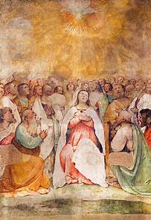
Intercessions for 8th June 2025
Pentecost

CELEBRANT: On this day of Pentecost when the Church is filled with the power of God’s Holy Spirit, united in Jesus we make our prayers to the Father.

READER: For the Church: that all who follow Christ will allow the Holy Spirit to penetrate their lives more deeply.
(Pause)
Lord, in your mercy
Hear our prayer
For peace in our world: that the Holy Spirit will transform our world into a community of justice and peace.
(Pause)
Lord, in your mercy
Hear our prayer
For ourselves and for our own parish community: that we may always be open to the gifts of the Spirit and accept with joy the challenges which lie ahead. (Pause)
Lord, in your mercy
Hear our prayer
For all who are sick or suffering, that the Holy Spirit will bring them strength, comfort and healing. (Pause)
Lord, in your mercy
Hear our prayer
For all who have died that they may see God face-to face.
(Pause)
Lord, in your mercy
Hear our prayer
We pray now to Our Blessed Lady as we say, Hail Mary….
Let us now pray quietly for a few moments.
Celebrant:
God our Father, open our hearts to the gifts of your Spirit that we may always walk in the light of your presence. Grant this through our Lord Jesus Christ who lives and reigns with you in the unity of the Holy Spirit one God for ever and ever. Amen

