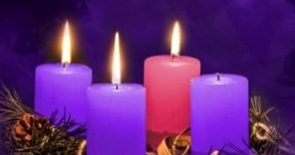
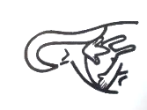
Intercessions for 14th December 2025
Third Sunday of Advent

Celebrant: Let us rejoice with all our hearts for the Spirit of the Lord has been given to us. As we prepare for his coming we pray for his help to be advocates for justice and help for those in need.
Reader: For our Holy Father, Pope Leo, and all our bishops, that they may continue to lead us in spreading the Word of God.
(pause)
Lord in your mercy
Hear our prayer

For missionaries everywhere, especially those far from home and family. May they be blessed with your mercy, kindness and inspiration.
(pause)
Lord in your mercy
Hear our prayer

For the people of the many lands plagued by conflict and violence, and for those trying to rebuild their lives and homes amid the destruction around them.
(pause)
Lord in your mercy
Hear our prayer

For the sick, those in hospital and those who are housebound, that they may feel the healing touch of God’s love.
(pause)
Lord in your mercy
Hear our prayer

For those who have recently died, and for all our dead; and for all who mourn, that they may be comforted.
(pause)
Lord in your mercy
Hear our prayer

We ask for the intercession of Our Blessed Lady, as we say: Hail Mary……

Let us pray quietly for a few moments.

Celebrant: Almighty God, as we continue this Advent journey, teach us to turn to You in times of joy and pleasure, as well as when faced with fear and sorrow. Help us to unite behind the great commission of Jesus to make disciples of all nations and all people. We make all our prayers through Christ Our Lord. Amen

